Current Activities & Acquisitions

An avid collector of all things IBM has donated a huge number of manuals, sales material, newspapers, magazines and company reports going back to the 1920s. A star of the manuals collection is a pristine 305 RAMAC manual that she says cost £500 on eBay some years ago!

Also included in the donation is a battery driven scale model of the IBM 705 operator’s console and a tape drive. The original 1960s Ever Ready leak-proof batteries, long dead, really haven’t leaked. Fitted with new batteries the console lights flash.
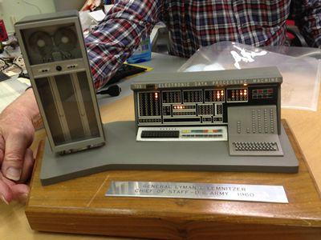
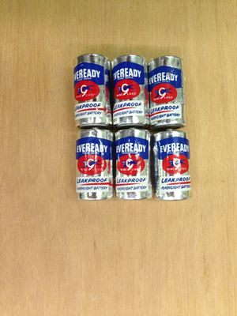

The model was presented by IBM to General Lyman Lemnitzer in 1960, we believe as an acknowledgement of the hard work he put in to adopt the 705 into the US military. We also have photographs and books about General Lemnitzer. This will make an excellent addition to the RAPC display in the museum.

The same collector has also promised us some of her hardware, including PCs, PS/2s and a US 115v volt DisplayWriter system.
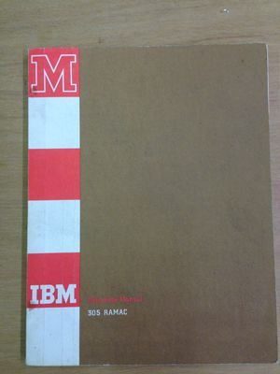
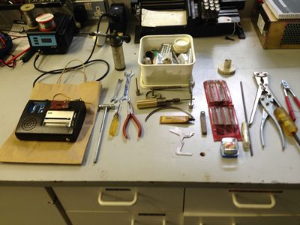

We have also received a selection of CE tools, a box of Selectric golf balls and a dictating machine.

